Name identifiers mindfully for ease of use.

1. Clairy
2. Naming conventions adopted by the organization

Each column has a specific data type and a maximum length you can use

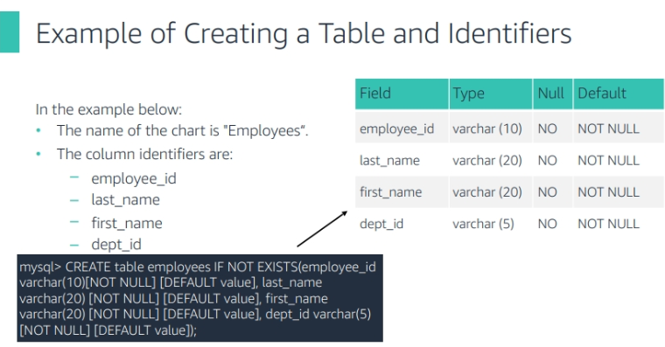



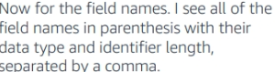

(employee_id varchar(10)[NOT NULL][DEFAULT VALUE]

